What is Weekly View?
The Common Core Studio presents a new Instruction Planner feature — Weekly View. This powerful feature is crucial for "just right" instruction.
Weekly View allows teachers to:
- Create lesson plans within the context of the week; allowing you to view the weekly progression of your lessons.
- Print a section or an entire daily/weekly lesson in PDF or Word format; never has it been easier to print lessons for administrators, substitutes, or even for personal reflection.
- Print and email plans from any computer with internet access.

Before you set up the system, users will see:
Administrative User — A link to the templates to select an element for teachers and administrators to view in the Weekly View. Please click here to set up Weekly View settings for the template. | 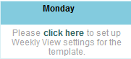
Teacher User — A message on each Weekly View day indicating a plan has been created and no element has been selected for the Weekly View option. Contact your Administrator to set up the template for Weekly View. | 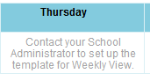

Administrative User —Setting Up Weekly View
- In an Administrative account, go to the School Templates and Elements menu.  - Select your default template or the template you wish to assign a Weekly View element. **Only text box elements may be selected and each template may have their own unique element. | 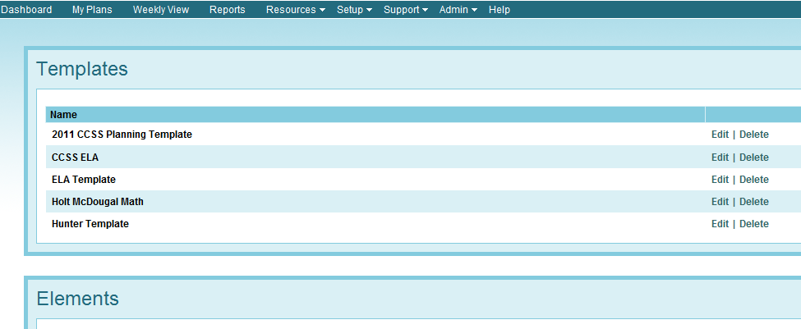
- Go to the Daily Plan of your template.  - A dropdown menu will appear with all of your text box elements.  - Select the element from the dropdown you wished displayed in the Weekly View feature; save the template. | 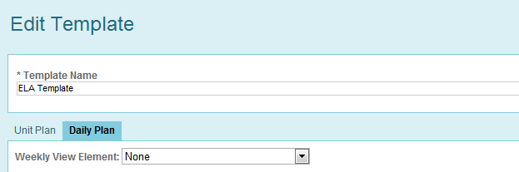

Teacher User — How do I use Weekly View?
- Select Weekly View from your menu.  - You will be brought to the current calendar week.  - Select the calendar on the left side of the page to navigate to another week in your planner.  - Use the arrows in the center of the screen to move forward or backward by week in your planner.  - The “This Week” link will return you to the current week.  - Selecting one of the magnifying glasses navigates you to your complete daily plan for that calendar day. | General Features  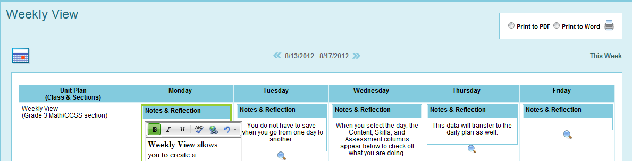  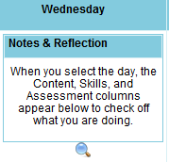
- Click in any of the element boxes and enter information.  - When finished, select a new day. Your information will be auto-saved. | Entering Data  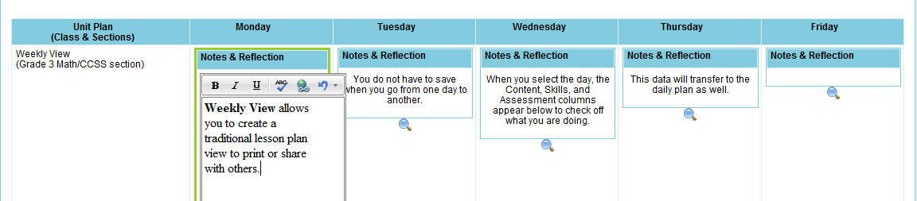
- If you have created a Content, Skills, and Assessment block, it will appear below your elements.  - Check off skills you will cover on this day. Your check marks will save in your Daily Plan as well. | 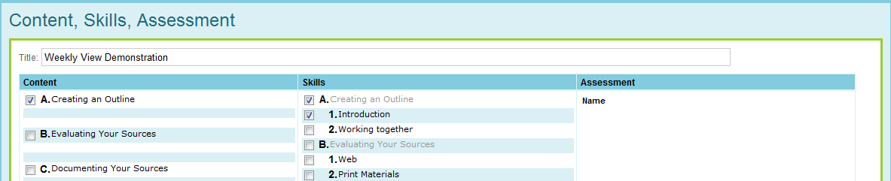
- Select the type of document you wish to produce.  - Click on the printer icon and your document will be created showing the element information displayed. | Printing Your Weekly View  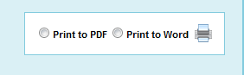

Teacher User – Go to your Daily Plan (Selecting the Magnifying Glass)
- From the Weekly View screen, select the magnifying glass for the day you wish to view or add additional information. You will be brought to the Daily Plan window.  ** The Calendar Bar at the top of the Daily Plan may now be hidden (Hide) allowing more of your plan to be viewed. | **New to Instruction Planner  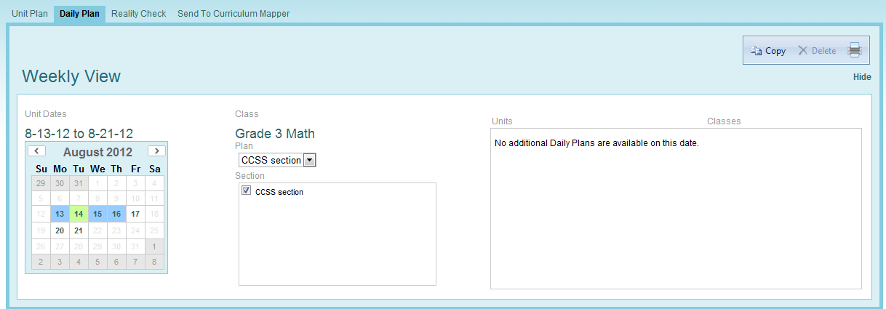
- Hide the Calendar Bar with the link in the right hand corner.  - The data entered in the Weekly View feature will be visible, allowing you to plan each individual day while viewing the element selected by your administrator.  - Selecting a different day from the Weekly View bar navigates you to the Daily Plan for that day, providing fast navigation for comparison or entering additional data. | 